

**By**

**Sunil Raj Thota**

**ALY6110 - Data Management and Big Data**

**Class Number: 202135**

**Class Name: Spring 2021 CPS Quarter – Second Half**

**CRN: 80524**

**Week 5 Assignment 1 – Azure Administration Essential Training**

**thota.su@northeastern.edu**

**Summary:**

Azure Administration Essential Training is a LinkedIn Learning course. The course covers the fundamentals of Azure, how to get started with Azure, how to create an Azure account, how to grasp Azure terminology and features, how to build your web app, how to network with Azure, and how to use virtual machines in Azure.

The list consists of the course's sections:

1. Introduction
2. Getting familiar with Microsoft Azure
3. Microsoft Azure Web Apps
4. Microsoft Azure Virtual Machine
5. Microsoft Azure Active Directory
6. Microsoft Azure Networking
7. Conclusion

**Content:**

**Introduction:**

Overview of Azure infrastructure, pricing, and Azure service subscriptions. A tour of the Microsoft Azure homepage and an introduction to the services.

1. **Getting familiar with Microsoft Azure**

Understanding cloud systems and their applications. Details on the services supplied by Azure, Azure Management tools, and cost control choices were reviewed in Chapter 1: Fundamentals of Cloud Computing. Data storage, computing, networking, and application services are all available with Azure. One of the most significant advantages is scalability.

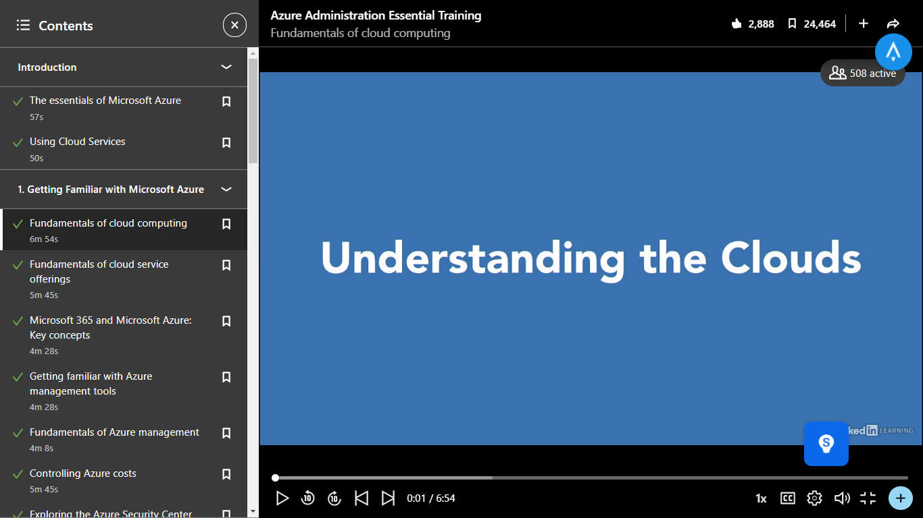

We also learned about the fundamentals of distributed computing. Hybrid clouds are a mix of public and private cloud infrastructure. We learned about the administrations that connect to Microsoft Azure, such as SaaS, PaaS, and others. We also learned how to connect to specific databases to store and retrieve data.

1. **Microsoft Azure Web Apps**

In this section, we'll look at the concept of web applications and how to create one in Azure. Developers and designers are the ones who write the code that runs beneath any asset. We learned about the different sorts of web apps available in Azure and how to make our own. Managing web applications was also reviewed, and participants were familiar with the available setups, as well as establishing and adding resources.

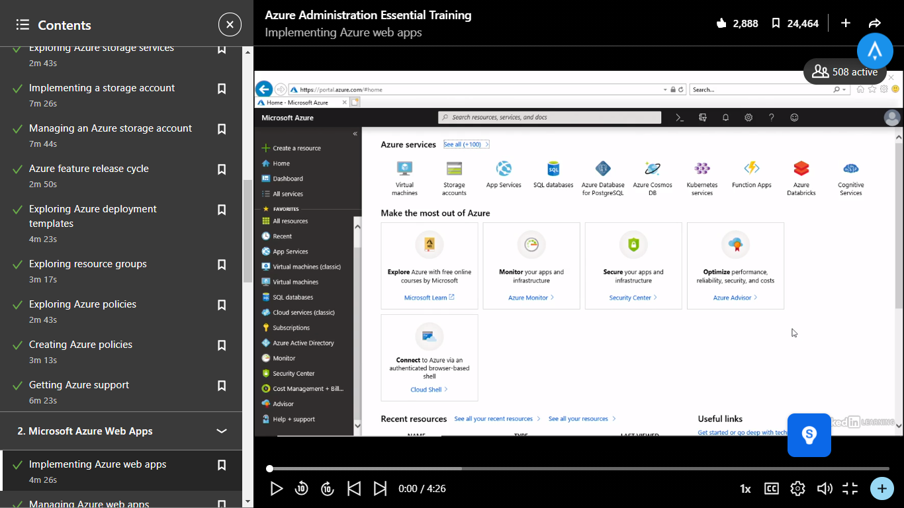

All of these web apps can be created in the Azure environment. We went over the steps for creating a web app and accessing it via a URL that was unique to that web app. We also learned how each web app is given its URL. This gives us the ability to organize resources on Azure, as well as a management plan for our assets and data.

1. **Microsoft Azure Virtual Machine**

The exact processes for building a VM were explained in Chapter 3. Processor selection, disk selection, networking, and management are among the phases. Azure provides the ability to set up effective security policies, use Windows licenses via Azure Hybrid, and perform backup and disaster recovery.

We also learned how to assign various resources to our virtual machines. We also learned how to set up a virtual machine, assign resource groups, and choose disks to run the new OS, such as SSD standard or premium or HDD standard. The next step is to configure and download the RDP file for connecting to the virtual machine through a virtual network or remote desktop. Azure provides an RDP file that allows users to access a VM built-in Azure by launching Remote Desktop Service on a local PC.

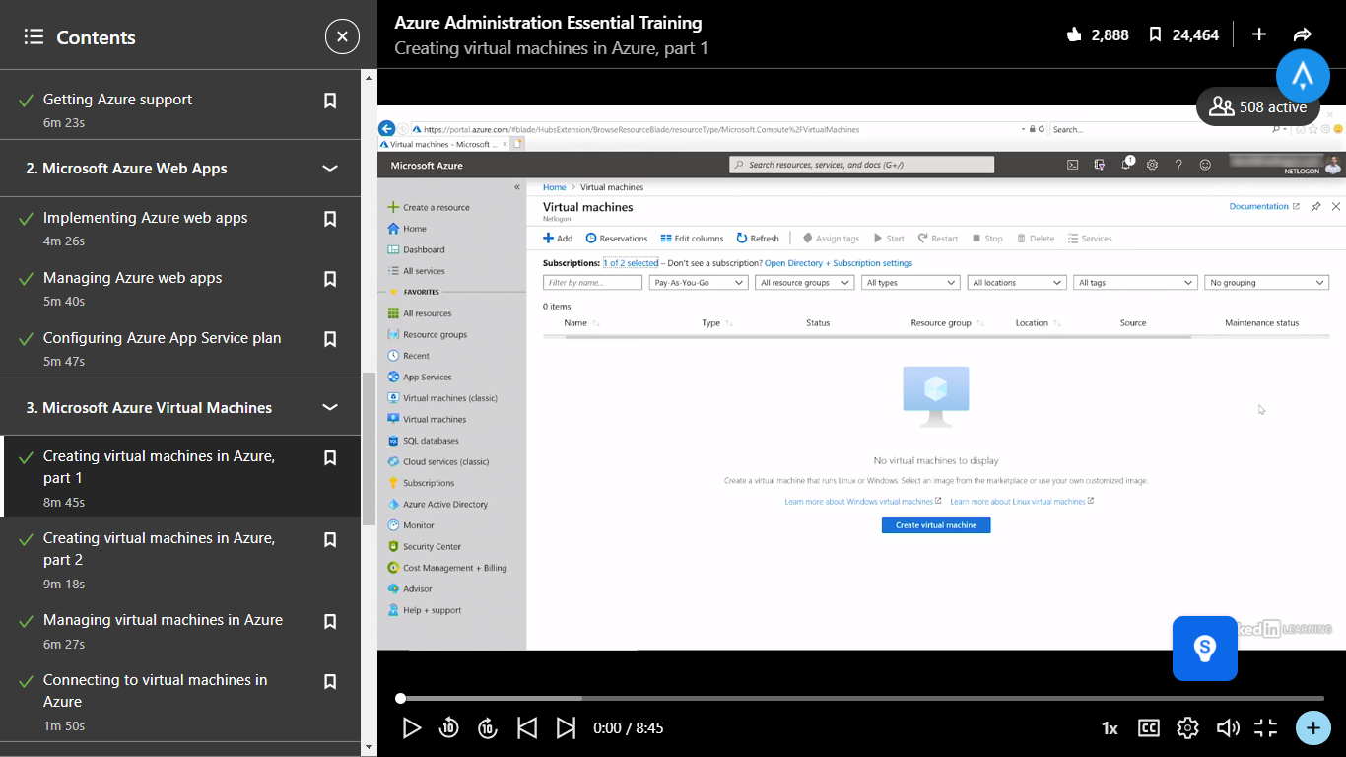

1. **Microsoft Azure Active Directory**

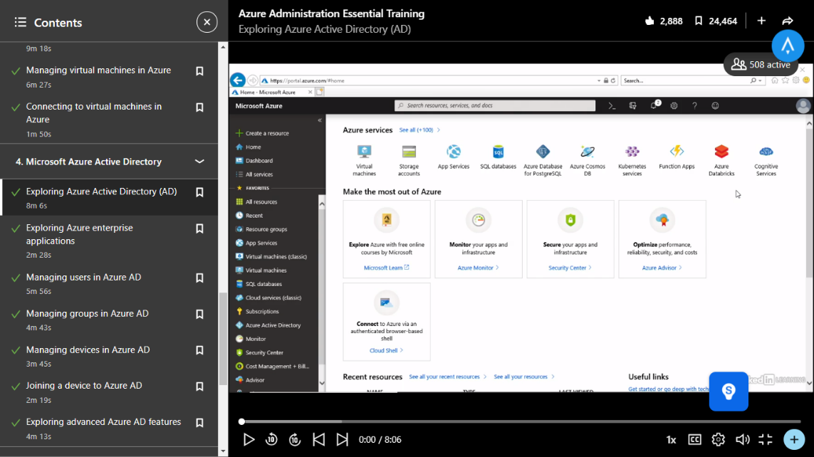

It is used by organizations that want to migrate resources from on-premises to Azure. In this section, we'll learn about the Active index, which provides verification and personality benefits to premises-based cloud users who are attempting to migrate to an Azure environment. A Microsoft cloud-based identity and access management service that allows your employees to sign in and access resources.

1. **Microsoft Azure Networking**

We'll look at networking with Azure and how to create virtual networks like VPNs. We also learned how to set up a VPN and the benefits of doing so. The burden balancer is a function that allows you to manage your associations. To create a VPN, Virtual Network Gateways is used. In Azure, we also learned about network security and DNS (Domain Name Server). The Azure Networking service has a lot of potentials.



**Conclusion:**

This certification covers the fundamentals of Azure, including how to deal with the company's cloud-based storage and networking services, which can scale up or down as the needs of the company change. Microsoft Azure is a massive cloud platform that offers more than 100 different services. These services are intended for usage with a variety of web-based applications, including Web apps, server apps, and additional features such as Virtual Machines, Scalable resources, Machine Learning models on big data platforms, and Huge data management APIs and resources, among others. The tutor went over Azure management tools, cost-cutting strategies, and how to use PowerShell scripting to manage Azure accounts and customize parameters.

**References:**

[1] David Elfassy. (Sept 12, 2019). Azure Essential Administration Training. *LinkedIn Learning*. Retrieved from https://www.linkedin.com/learning/azure-administration-essential-training/the-essentials-of-microsoft-azure?u=74653650

**Certification:**

